**Assignment 3**

**Problem statement :**

Program on HTML basic tags to create forms and UI elements.

The objective is to create a simple HTML webpage that demonstrates how to handle various multimedia elements such as images, audio, and video. The page should allow users to view an image, listen to an audio file, and watch a video, using the appropriate HTML tags to ensure proper embedding and functionality across different web browsers.

The objective of this project is to create a simple and functional HTML form that allows users to input their personal information. This form will demonstrate various HTML form elements and UI components, enabling users to interactively provide data. The goal is to familiarize oneself with the structure and behavior of forms in HTML, ensuring that the form is user-friendly and visually appealing.

**Steps to Create the HTML Form**

1. **Set Up the HTML Document**:
   * Begin by declaring the document type with <!DOCTYPE html>.
   * Open the <html> tag and specify the language using lang="en".
   * Inside the <head> tag, include metadata such as character set (<meta charset="UTF-8">) and viewport settings (<meta name="viewport" content="width=device-width, initial-scale=1.0">).
   * Set the title of the page with <title>.
2. **Add CSS for Styling**:
   * Use the <style> tag within the <head> section to define CSS rules for the body, headings, form elements, and buttons. This helps improve the visual appearance and layout of the form.
   * Style the body with a specific font and margin.
   * Style headers (<h1>, <h2>) for color and spacing.
   * Add styles for form elements such as padding, borders, and background colors to create an attractive layout.
3. **Create the Form Structure**:
   * Insert the <form> tag with attributes like action="#" (indicating where to send the form data) and method="post" (to specify the data submission method).
   * Add various input fields within the form, ensuring each has an associated <label> for accessibility and clarity.
4. **Add Input Fields**:
   * **Text Input**: Use <input type="text"> for the user’s name and email, ensuring these fields are marked as required with the required attribute.
   * **Phone Input**: Include <input type="tel"> for a phone number input.
   * **Radio Buttons**: Create a group of radio buttons for gender selection, ensuring they share the same name attribute so only one can be selected.
   * **Checkboxes**: Provide checkboxes for hobby selection, allowing users to choose multiple options.
   * **Dropdown Menu**: Use the <select> tag to create a dropdown for selecting a country.
   * **Textarea**: Add a <textarea> for users to input a message, with specified rows for height.
5. **Add a Submit Button**:
   * Include an <input type="submit"> button at the end of the form to allow users to submit their data.
6. **Test the Form**:
   * Save the file with a .html extension (e.g., form_example.html).
   * Open the file in a web browser and interact with the form to ensure it works as expected.
   * Check the functionality of each input field and the overall layout.

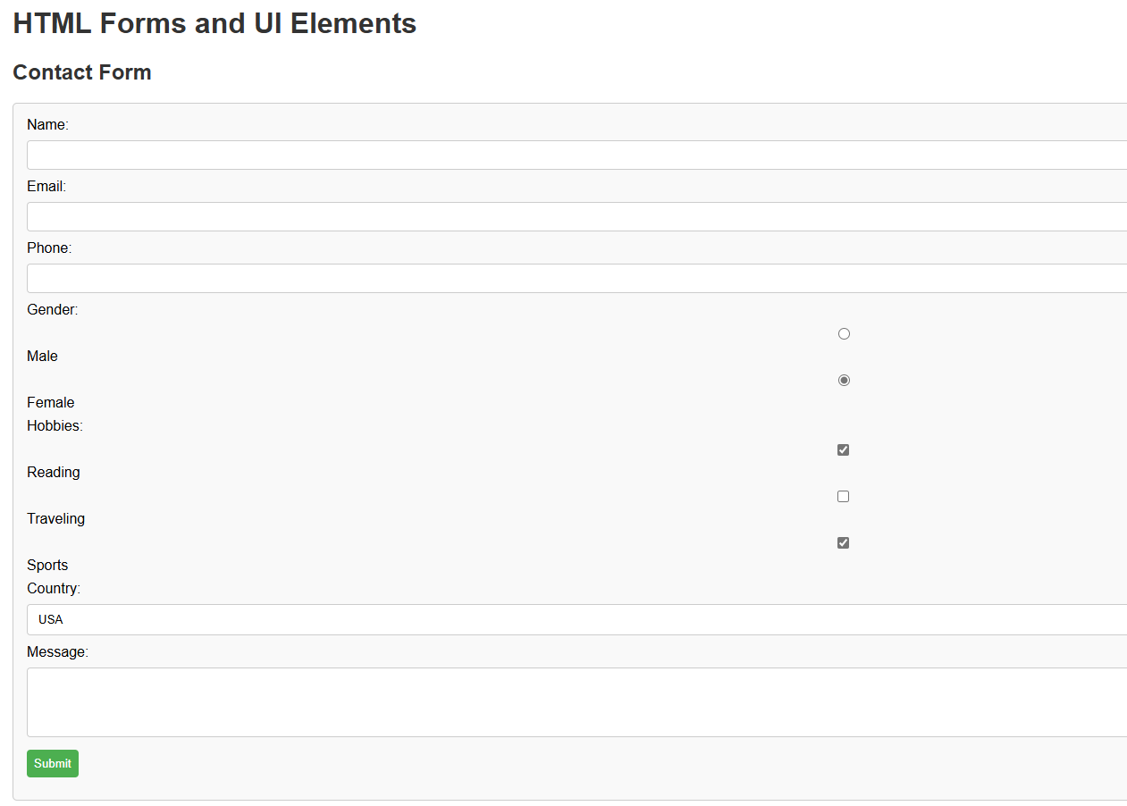**Screenshot of output:**